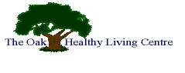

Stop Smoking

**12 weekly Stop Smoking Support Group**

**Or One to One Support**

Every Wednesday at 8.00pm

Oak Healthy Living Centre



The LITE House, Cross Street, Lisnaskea, Co Fermanagh

**Tel: Patricia on 07593446202**

Healthy Living Centre Alliance 