Your Video Group Clinic Agreement
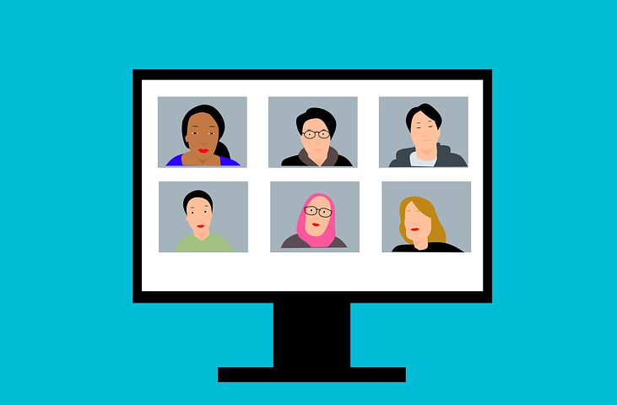

By participating in this video group clinic (VGC) I agree that:

- I am happy to share some information about my condition that relates to the group’s topic. For example, this might include my average blood sugar readings, peak flow meter readings, my blood pressure, body mass index or cholesterol levels etc. These results will be shared with the group on a “results board” to support group discussion and my learning. I will then have a one-to-one discussion about my concerns. Other members of the group will listen in, and in turn I will listen to their one-to-one discussions, so that we can all benefit from hearing and understanding common problems and solutions.

- I am under no obligation to share any other personal information with the group unless I choose to do so and that if I have health concerns I don’t want to discuss in the group setting, I may ask to discuss them privately in a 1:1 consultation.

- At any time, I can withdraw my consent to participate in the video group clinic and book a 1:1 consultation.

- All information I learn about group members is confidential. I agree that I will record nor share any information about other members of the group in conversations outside the group, or on social media such as Facebook, Twitter etc or in any other public forum.

If you have any questions about video group clinics, please watch this video https://www.youtube.com/watch?v=zwBPrWeLe0E , read our frequently asked questions (attached) and see also under Services on our Website https://maple.gpsurgery.net/ ), where you will find more information about VGC in Maple Healthcare. You can also ask to speak to our co-ordinator Rosemary Stockdale to explain more before the session by ringing the clinic (028-67721556) or sending her a text by using Patient triage https://florey.accurx.com/p/Z00574

