
Come to work in “The happiest place to live in the UK”!
http://www.theguardian.com/uk-news/2015/sep/23fermanagh-and-omagh-top-happiness-scale

Maple Healthcare
44 Drumhaw Park, Lisnaskea, Co. Fermanagh BT92 0GT
Branch - 5 Clones Road, Newtownbutler
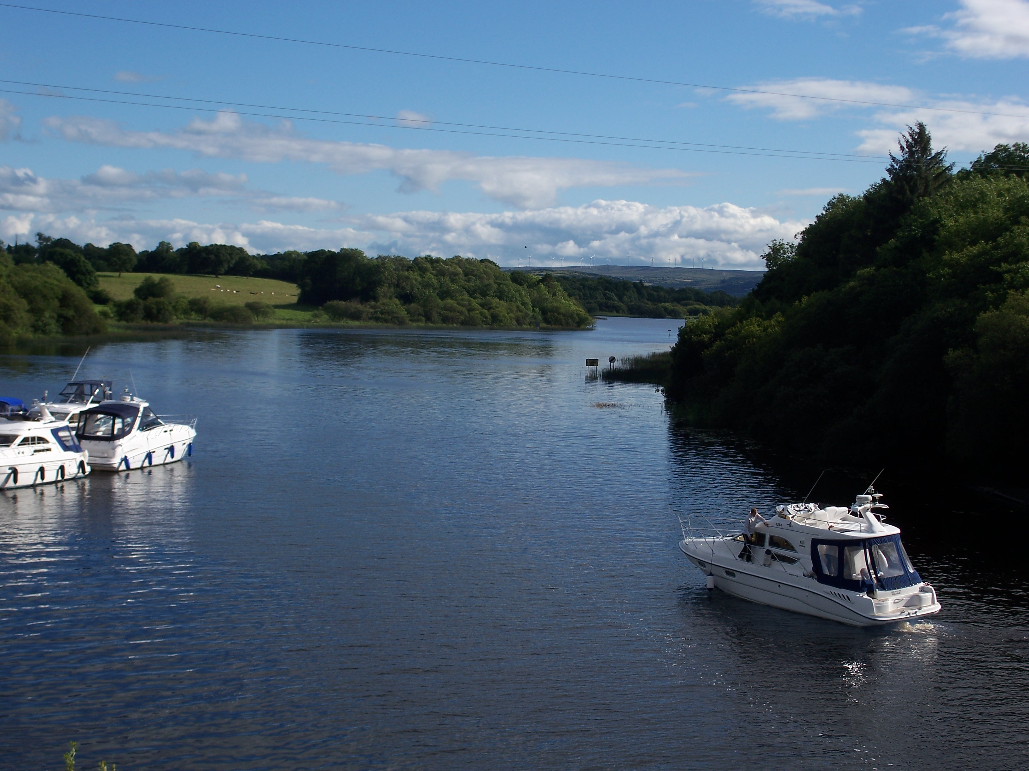
http://www.fermanaghlakelands.com

Are Recruiting!
General Practitioner
Locum/Salaried GP with view to Partnership

- Indemnity covered in addition to salary
- 6 weeks annual leave plus bank holidays (pro-rata)
- NHS Pension enrolment
- Large team of GPs and wider primary care team for support and learning
- Trust owned health centre (no buy-in)
- Teaching Practice
- High QoF achievement
- Fully computerised, paper-light accredited
- EMIS WEB clinical system.
- Using AccuRx and iGPR software
- Friendly, multi-disciplinary primary care team
- Trust managed treatment room
- Home visit GP
- Urgent Team working (GP and Nurse Practitioners)
- Remote Doctor working
- Bi- Weekly Multidisciplinary Team meeting
- Monthly Governance Meeting with all clinicians
- RCGP Quality Practice Award 2014-2019
- Good quality schools in the area
- Speak to two of our Partners who have already made the move to Northern Ireland

For further details please contact:
Maria Nugent-Murphy,
Practice Manager,
Maple Healthcare
44 Drumhaw Park, Lisnaskea
Co. Fermanagh BT92 0GT
Telephone: (028) 6772 1566
E-mail: gp.Z00574@gp.hscni.net

